Project Design Phase

The Project Design Phase focuses on transforming the defined requirements into a structured and implementable system design. This phase bridges the gap between problem understanding and system implementation. It ensures that the proposed solution effectively addresses the identified problem while remaining technically feasible, scalable, and efficient. The design phase for the Motor Temperature Prediction project is divided into four sub-phases: Problem–Solution Fit, Problem Solution Analysis, Proposed Solution, and Solution Architecture.

1. Problem–Solution Fit
The Problem–Solution Fit sub-phase evaluates how well the identified solution aligns with the problem defined during the ideation and requirement analysis phases. This step ensures that the solution directly addresses user pain points and system limitations.
1.1 Identified Problem Recap
Electric motor overheating is a critical issue that leads to:
- Unexpected motor failures
- Increased downtime
- High maintenance costs
- Reduced motor lifespan
Traditional monitoring systems are reactive and fail to predict temperature rise in advance.

1.2 Alignment of Solution with Problem
The proposed machine learning-based motor temperature prediction system aligns with the problem in the following ways:
- Predictive Capability
Instead of reacting to threshold violations, the system predicts future motor temperature trends.
- Data-Driven Decision Making
Uses historical and real-time sensor data to generate accurate predictions.
- Early Fault Detection
Enables preventive actions before overheating causes damage.
- Reduced Dependency on Physical Sensors
Predicts temperature using indirect operational parameters.
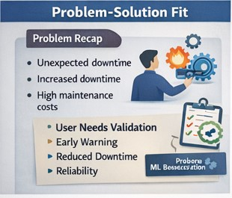

1.3 User-Centric Validation
From the empathy mapping and customer journey analysis:
- Users need early warnings → Solution provides advance predictions
- Users want reduced downtime → Solution enables planned maintenance
- Users need reliability → ML models improve accuracy over time
Thus, the proposed system demonstrates a strong problem–solution fit.

